EXPERIMENT – 9
Implement Image Scaling Techniques to Resize Images to Bigger and Smaller Sizes
Aim
To resize an image to bigger and smaller sizes using Python and OpenCV.
Procedure
- Import the OpenCV library.
- Read the input image using cv2.imread().
- Check whether the image is loaded successfully.
- Resize the image to a bigger size using cv2.resize().
- Resize the image to a smaller size using cv2.resize().
- Display the original, enlarged, and reduced images.
- Wait for a key press and close all image windows.
Program
import cv2

image = cv2.imread("image.jpg")

if image is None:
print("Image not found!")
else:
bigger = cv2.resize(image, None, fx=2, fy=2)
smaller = cv2.resize(image, None, fx=0.5, fy=0.5)

cv2.imshow("Original Image", image)
cv2.imshow("Bigger Image", bigger)
cv2.imshow("Smaller Image", smaller)

cv2.waitKey(0)
cv2.destroyAllWindows()

Sample Input
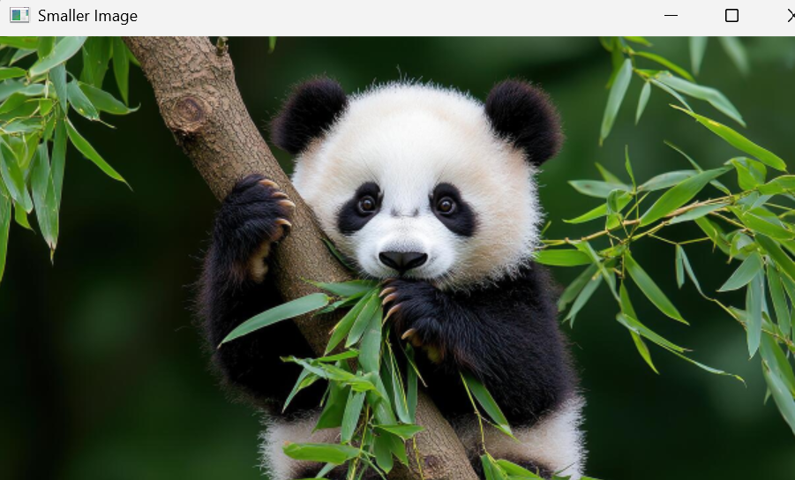
Sample Output
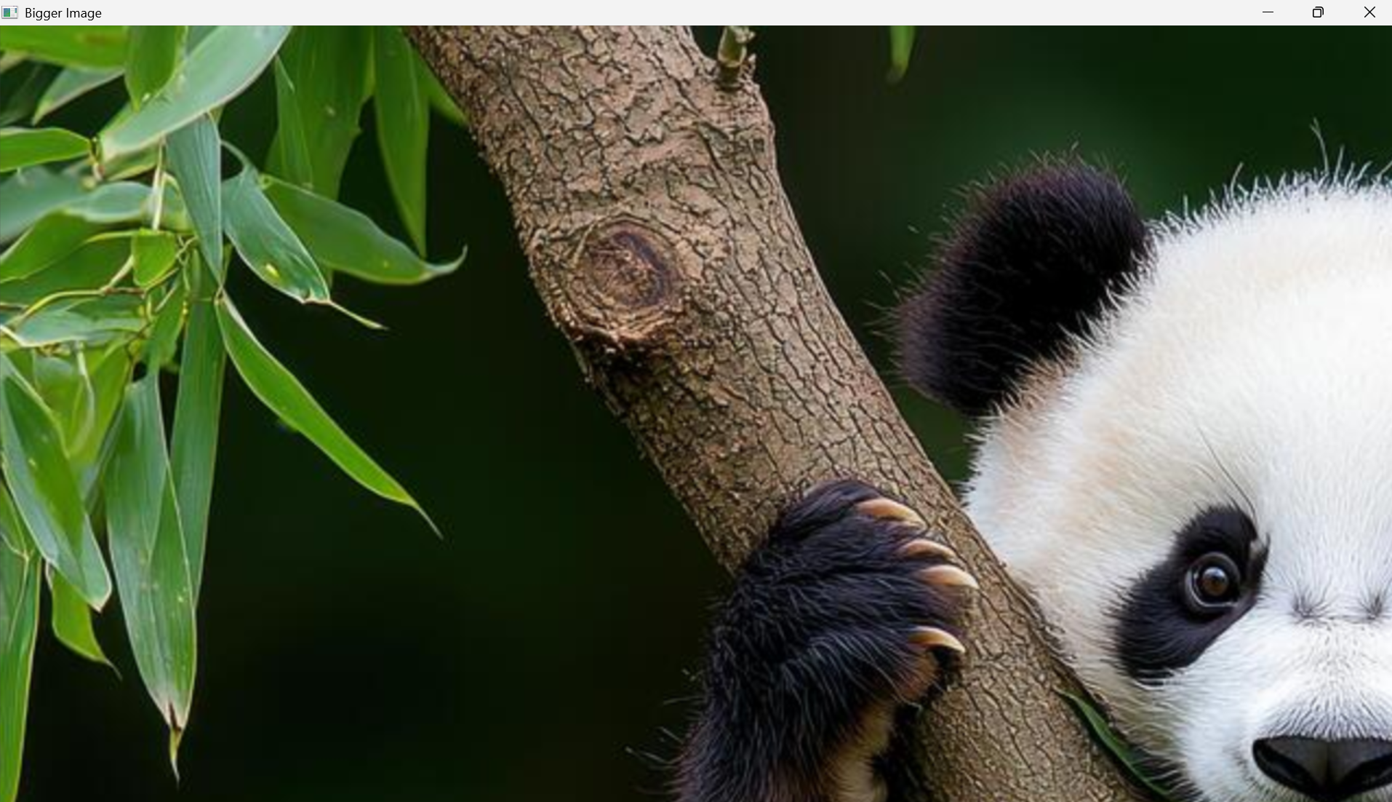
- Original image
- Enlarged image (2 times bigger)
- Reduced image (half the original width and height)
Result
Thus, the image was successfully resized to bigger and smaller sizes using Python and OpenCV.

